**HTML Assignment - 1**

**1)<!DOCTYPE html>**

**<html>**

**<head>**

**<body style="background-color:yellow;"></body>**

**<h1 style="background-color: red;">This is heading</h1>**

**<h2 style="background-color: green;">This is paragraph</h2>**

**</head>**

**</html>**

**Output:**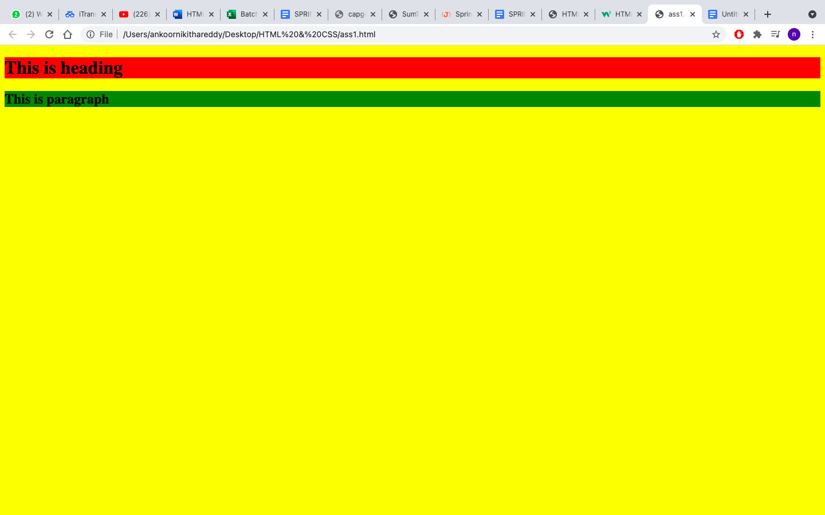

**2) <!DOCTYPE html>**

**<html>**

**<head>**

**<body>**

**<h2>Image with border</h2>**

**<img src="simley.jpg" alt="simley image" border="1">**

**<h2>Image with out border</h2>**

**<img src="simley.jpg" alt="simley image">**

**</body>**

**</head>**

**</html>**

**Output:**

**3) <!DOCTYPE html>**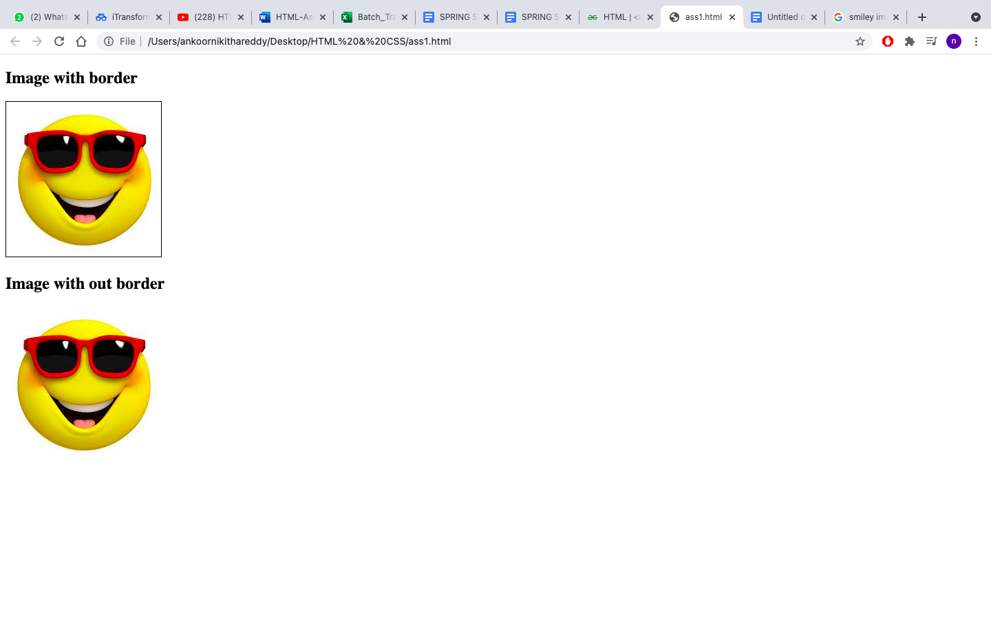

**<html>**

**<body>**

**<p>One Column:</p>**

**<table border="1">**

**<tr>**

**<td>100</td>**

**</tr>**

**</table>**

**<p>One row and three columns:</p>**

**<table border="1">**

**<tr>**

**<td>100</td>**

**<td>200</td>**

**<td>300</td>**

**</tr>**

**</table>**

**<p>One row and three columns:</p>**

**<table border="1">**

**<tr>**

**<td>100</td>**

**<td>200</td>**

**<td>300</td>**

**</tr>**

**<tr>**

**<td>400</td>**

**<td>500</td>**

**<td>600</td>**

**</tr>**

**</table>**

**</body>**

**</html>**

**Output:**

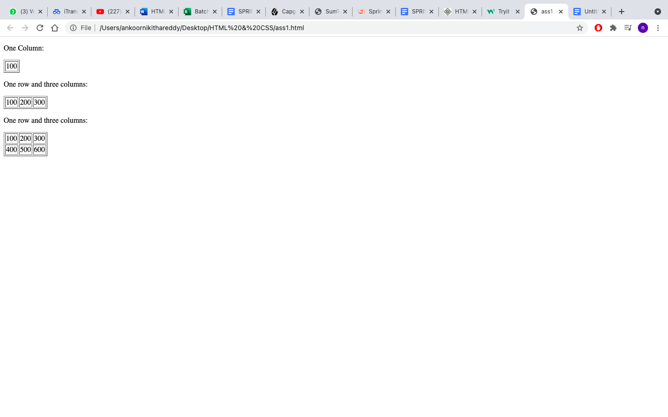

**4) <!DOCTYPE html>**

**<html>**

**<body>**

**<p>This table has borders:</p>**

**<table border="1">**

**<tr>**

**<td>100</td>**

**<td>200</td>**

**<td>300</td>**

**</tr>**

**<tr>**

**<td>400</td>**

**<td>500</td>**

**<td>600</td>**

**</tr>**

**</table>**

**<p>And table has no borders:</p>**

**<table>**

**<tr>**

**<td>100</td>**

**<td>200</td>**

**<td>300</td>**

**</tr>**

**<tr>**

**<td>400</td>**

**<td>500</td>**

**<td>600</td>**

**</tr>**

**</table>**

**</body>**

**</html>**

**Output:**

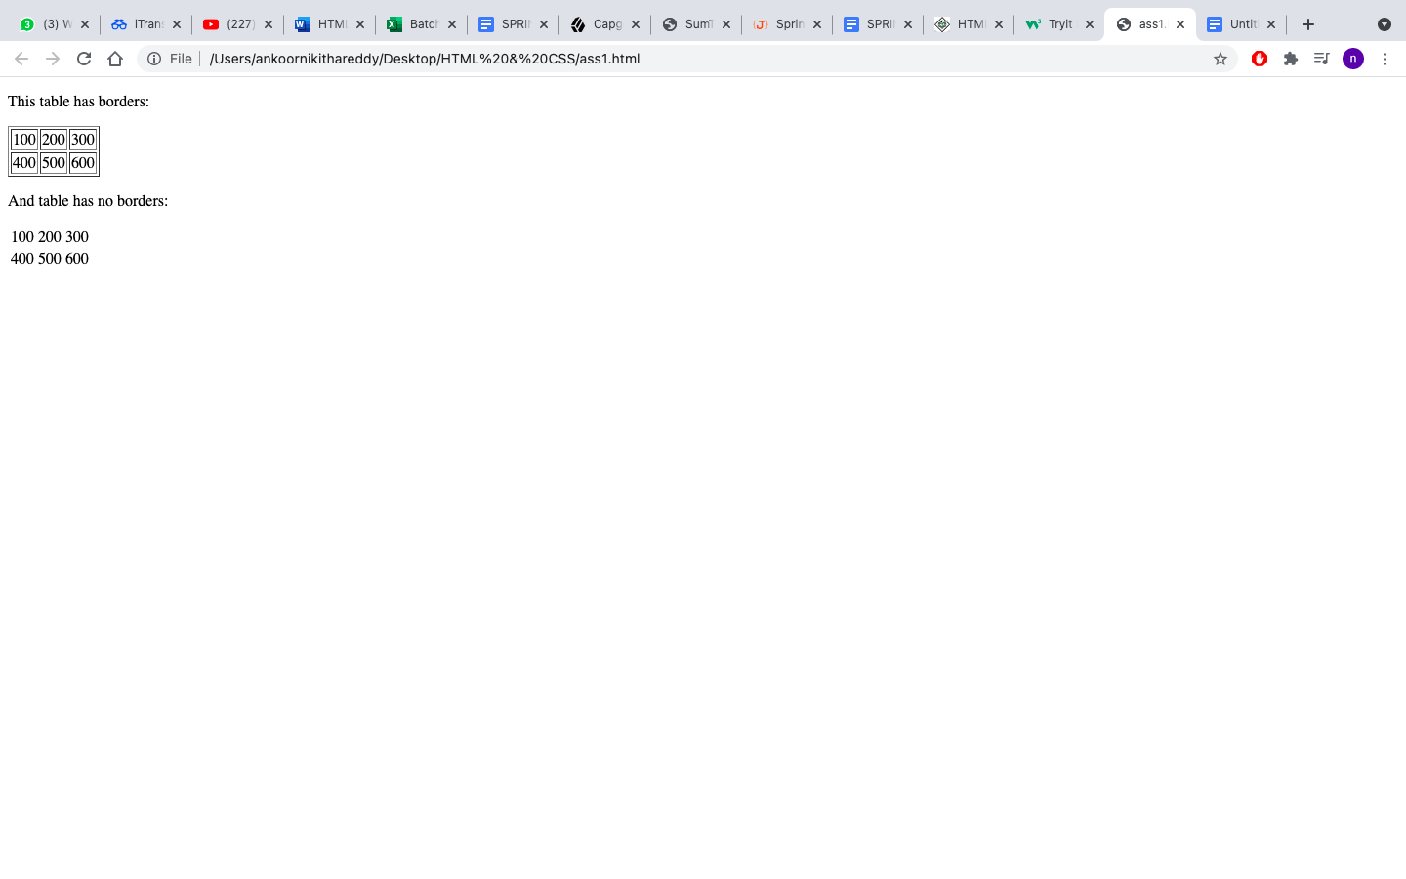

**5) <!DOCTYPE html>**

**<html>**

**<title>HTML Ordered List</title>**

**</head>**

**<body>**

**<h2>Numbered list:</h2>**

**<ol type = "1">**

**<li>Apples</li>**

**<li>Bananas</li>**

**<li>Lemons</li>**

**<li>Oranges</li>**

**</ol>**

**<h2>Letters list:</h2>**

**<ol type = "A">**

**<li>Apples</li>**

**<li>Bananas</li>**

**<li>Lemons</li>**

**<li>Oranges</li>**

**</ol>**

**<h2>Lowercase letters list:</h2>**

**<ol type = "a">**

**<li>Apples</li>**

**<li>Bananas</li>**

**<li>Lemons</li>**

**<li>Oranges</li>**

**</ol>**

**<h2>Roman numbers list:</h2>**

**<ol type = "I">**

**<li>Apples</li>**

**<li>Bananas</li>**

**<li>Lemons</li>**

**<li>Oranges</li>**

**</ol>**

**<h2>Lowercase roman numbers list:</h2>**

**<ol type = "i">**

**<li>Apples</li>**

**<li>Bananas</li>**

**<li>Lemons</li>**

**<li>Oranges</li>**

**</ol>**

**</body>**

**</head>**

**</html>**

**Output:**

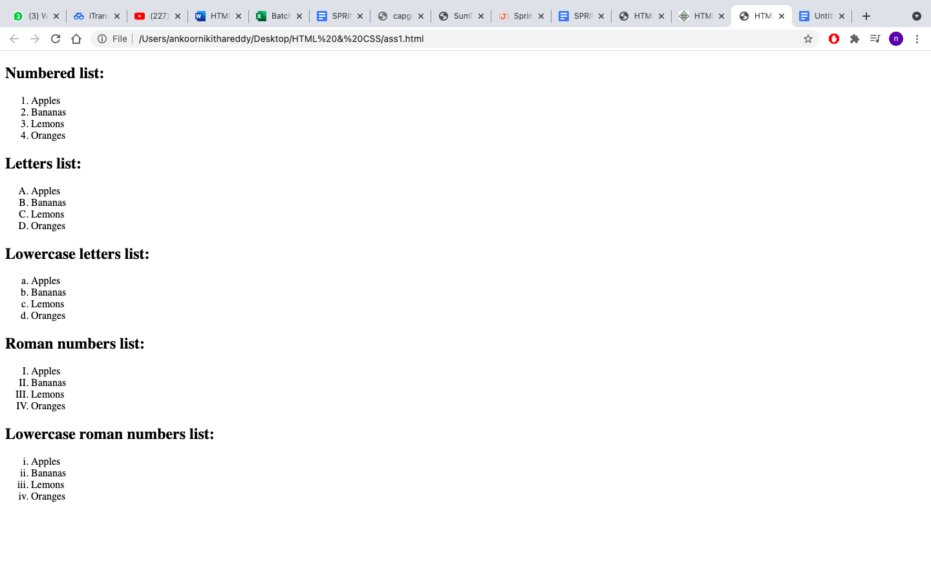

**6) <!DOCTYPE html>**

**<html>**

**<head>**

**<title>HTML Forms</title>**

**</head>**

**<body>**

**<form>**

**<label for="username"> Username:</label>**

**<input type="text" id="username" name="username">**

**<br><br>**

**<label for="password">Password:</label>**

**<input type="password" id="password" name="password"><br>**

**</form>**

**</body>**

**</html>**

**Output:**

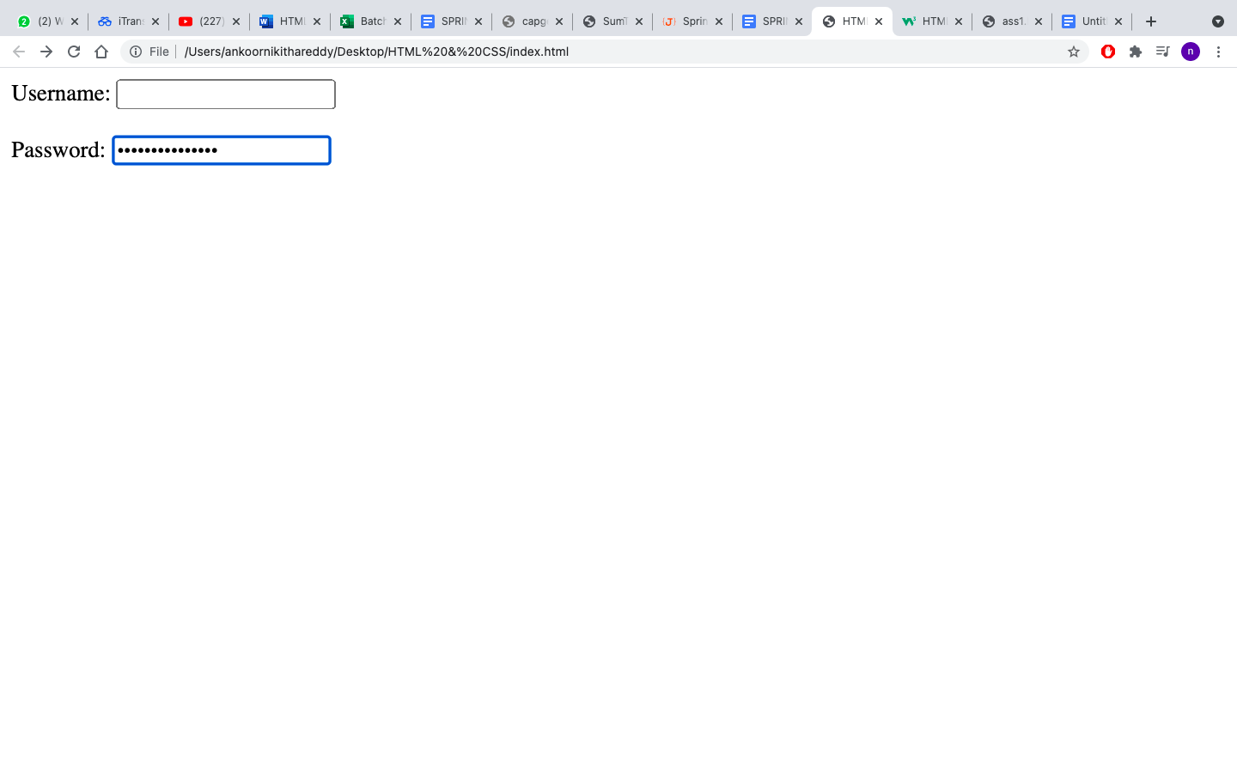

**7) <!DOCTYPE html>**

**<html>**

**<head>**

**<input type="checkbox" id="option-1">**

**<label for="option-1">I have a bike</label>**

**<br><br>**

**<input type="checkbox" id="option-2">**

**<label for="option-1">I have a car</label>**

**<br><br>**

**<input type="submit" value="Submit">**

**</head>**

**</html>**

**Output:**

**8th and 9th:**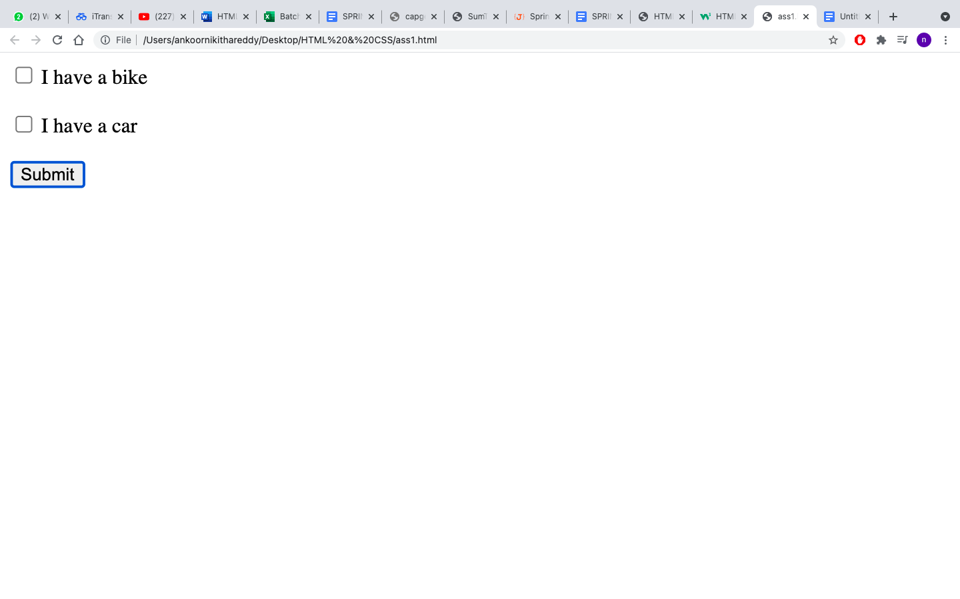

**<!DOCTYPE html>**

**<html>**

**<head>**

**<body>**

**<table border="1">**

**<tr>**

**<tr style="background-color: darkgreen;">**

**<th>top</th>**

**</tr>**

**<tr>**

**<td style="background-color: gray;height: 50px;width: 50px;">left</td>**

**<td style="background-color:lightgray;height: 50px;width: 50px;">right</td>**

**</table>**

**<br><br>**

**<table border="1">**

**<tr>**

**<td style="background-color: lightgray;">topleft</td>**

**<td style="background-color:gray;">topright</td>**

**</tr>**

**<tr>**

**<td style="background-color: gray; height: 50px;">botleft</td>**

**<td style="background-color: lightgray;">botright</td>**

**</tr>**

**</table>**

**</body>**

**</head>**

**</html>**

**Output:**

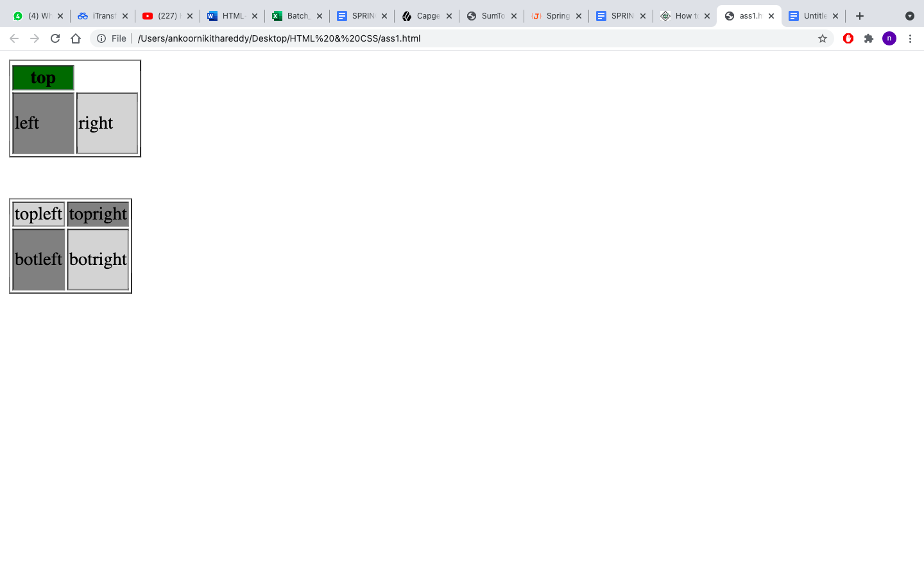

**CSS ASSIGNMENT - 1**

**1)index.html**

**<!DOCTYPE html>**

**<html>**

**<head>**

**<link rel="stylesheet" href="style.css">**

**<title>HTML Forms</title>**

**</head>**

**<body style="background-color: rgb(214, 237, 245);">**

**<h1>CSS background-color example!</h1>**

**<div>This is a text inside a div element</div>**

**<p>This paragraph has its own background color</p>**

**<div>We are still in the div element</div>**

**</html>**

**Style.css**

**h1{**

**background-color: blue;**

**padding: 30px;**

**}**

**div{**

**background-color: dimgray;**

**padding: 30px;**

**}**

**p{**

**background-color: rgb(214, 237, 245);**

**}**

**Output:**

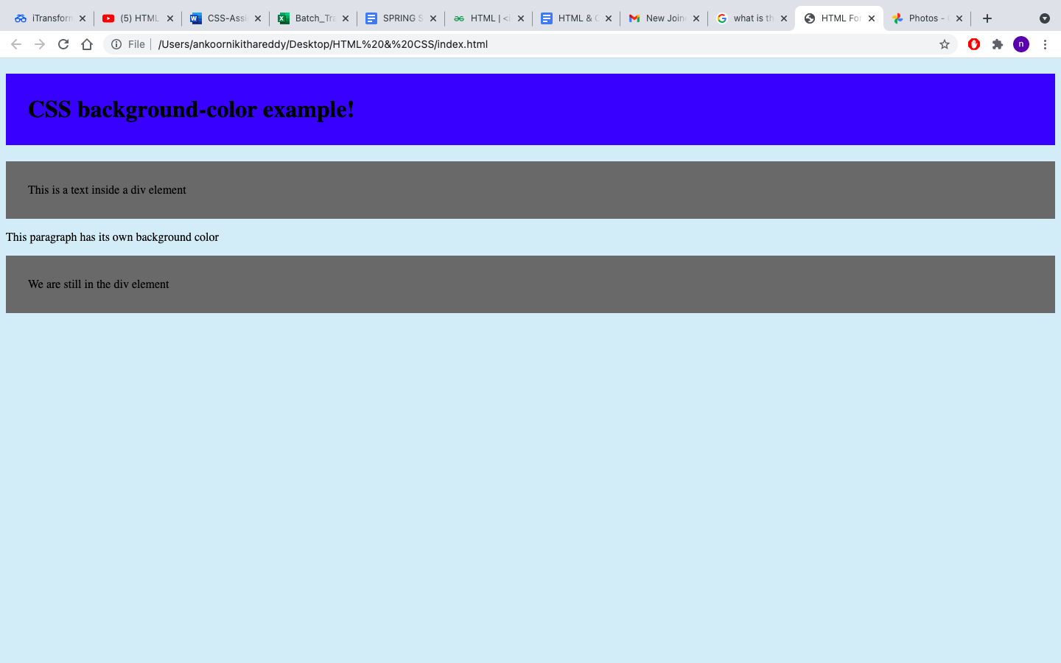

**2) index.html**

<!DOCTYPE html>

<html>

<head>

<link rel="stylesheet" href="style.css">

<title>HTML Forms</title>

</head>

<body style="background-color: rgb(214, 237, 245);">

<h1>This is heading 1</h1>

<h2>This is heading 2</h2>

<h3>This is heading 3</h3>

<h4>This is heading 4</h4>

</html>

**style.css**

**h2{**

**text-decoration: line-through;**

**}**

**h3{**

**text-decoration: underline;**

**}**

**Output:**

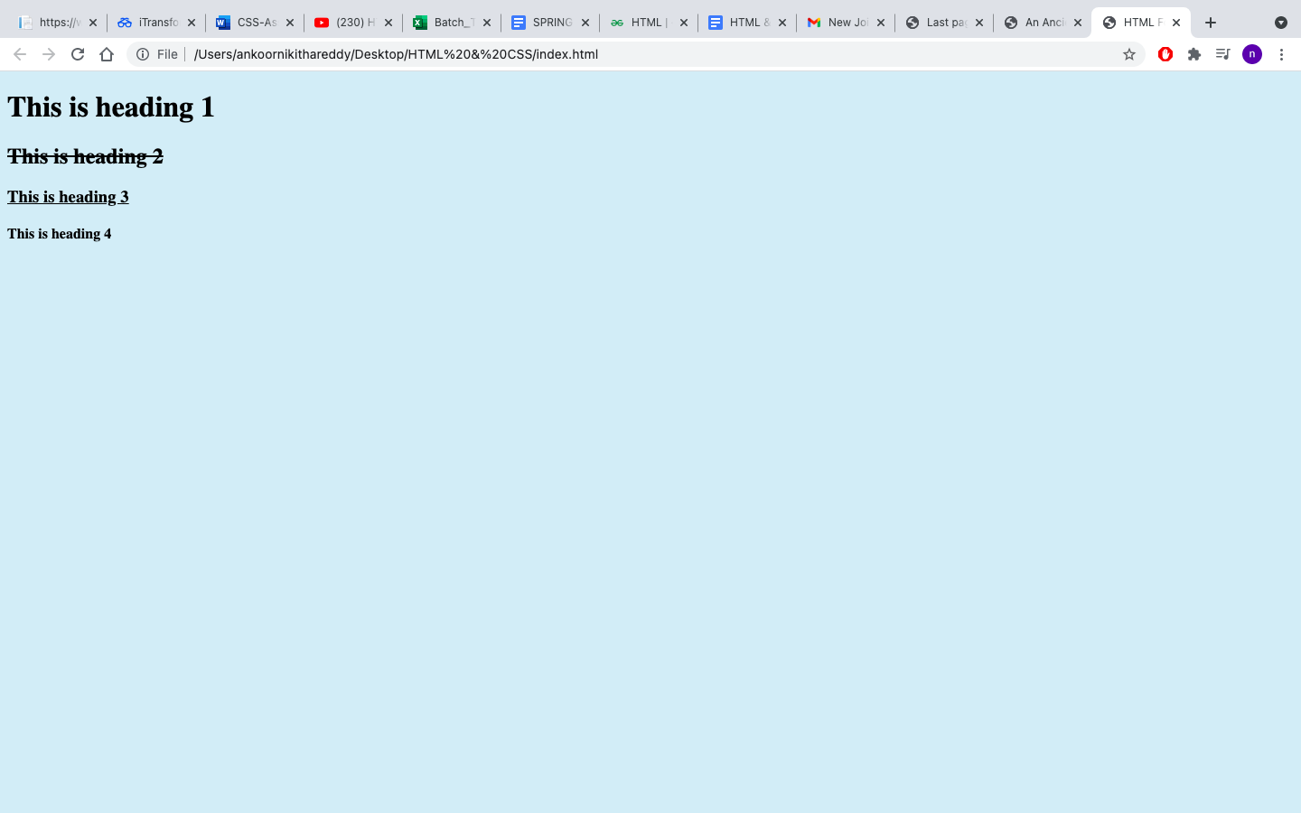

**4) Index.html**

**<!DOCTYPE html>**

**<html>**

**<head>**

**<link rel="stylesheet" href="style1.css">**

**<body>**

**<h2 class="link">**

**<a href="https://www.w3schools.com">This is a link</a>**

**</h2>**

**</body>**

**</head>**

**</html>**

**style.css**

**.link{**

**background-color: lightblue;**

**text-emphasis-color: red;**

**}**

**.link:visited{**

**color: red;**

**}**

**Output:**

**3) Index.html**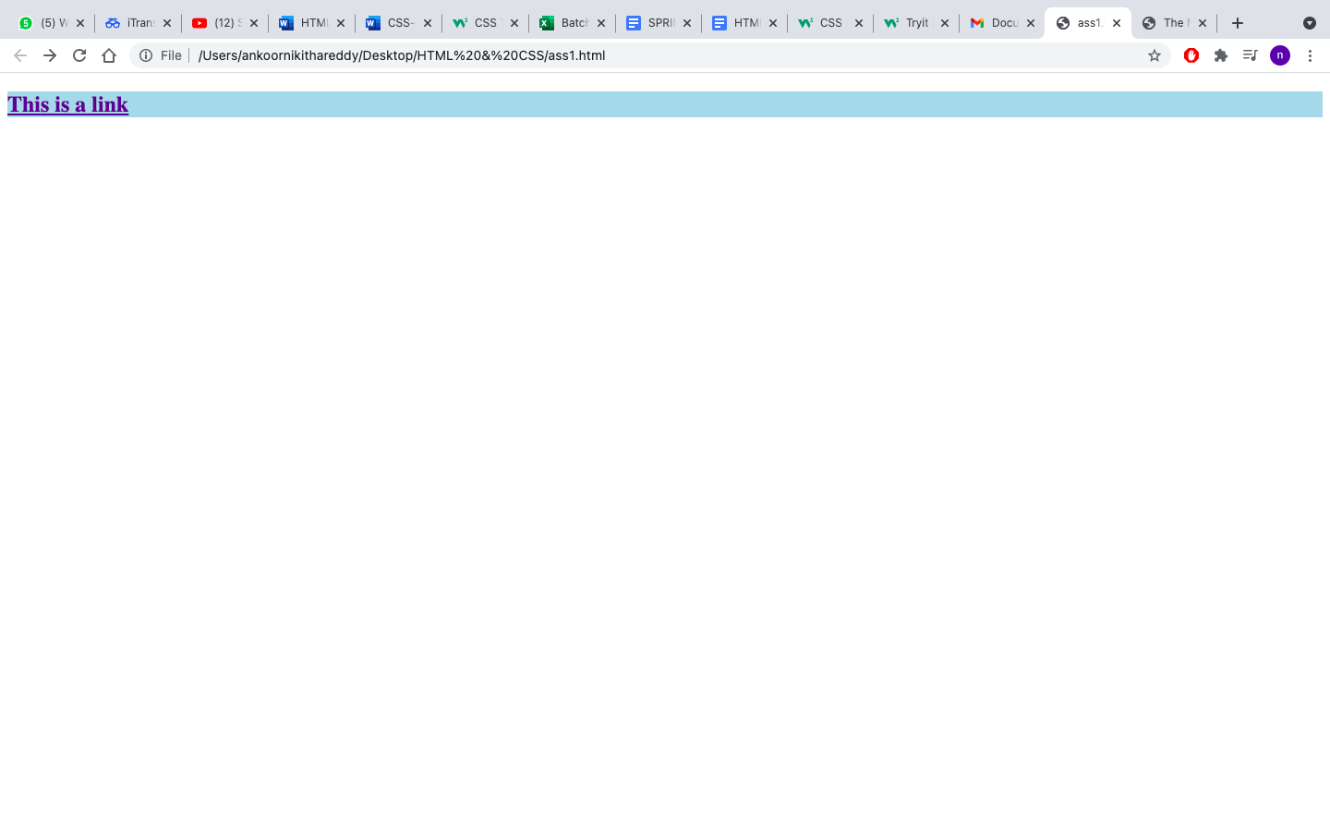

**<!DOCTYPE html>**

**<html>**

**<head>**

**<link rel="stylesheet" href="style1.css">**

**<body>**

**<div class="question">**

**<h2>THIS IS SOME TEXT</h2>**

**<h2>this is some text</h2>**

**<h2>this is some text</h2>**

**</div>**

**</body>**

**</head>**

**</html>**

**style1.css**

**.question{**

**background-color: lightblue;**

**}**

**Output:**

**5)index.html**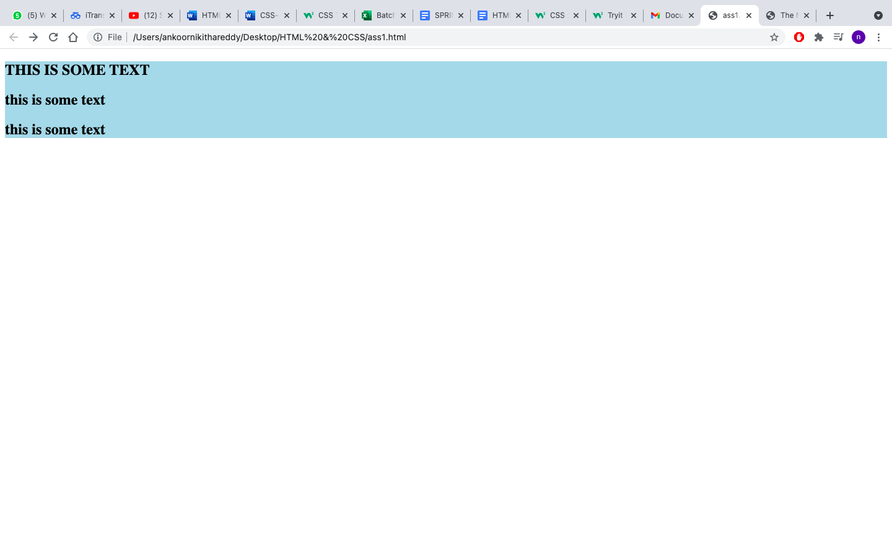

**<!DOCTYPE html>**

**<html>**

**<head>**

**<link rel="stylesheet" href="style1.css">**

**<body>**

**<table>**

**<tr>**

**<th>Firstname</th>**

**<th>Lastname</th>**

**</tr>**

**<tr>**

**<td>Peter</td>**

**<td>Griffin</td>**

**</tr>**

**<tr>**

**<td>Lois</td>**

**<td>Griffin</td>**

**</tr>**

**</table>**

**</body>**

**</head>**

**</html>**

**Style.html**

**table, th, td {**

**border: 1px solid black;**

**}**

**Output:**

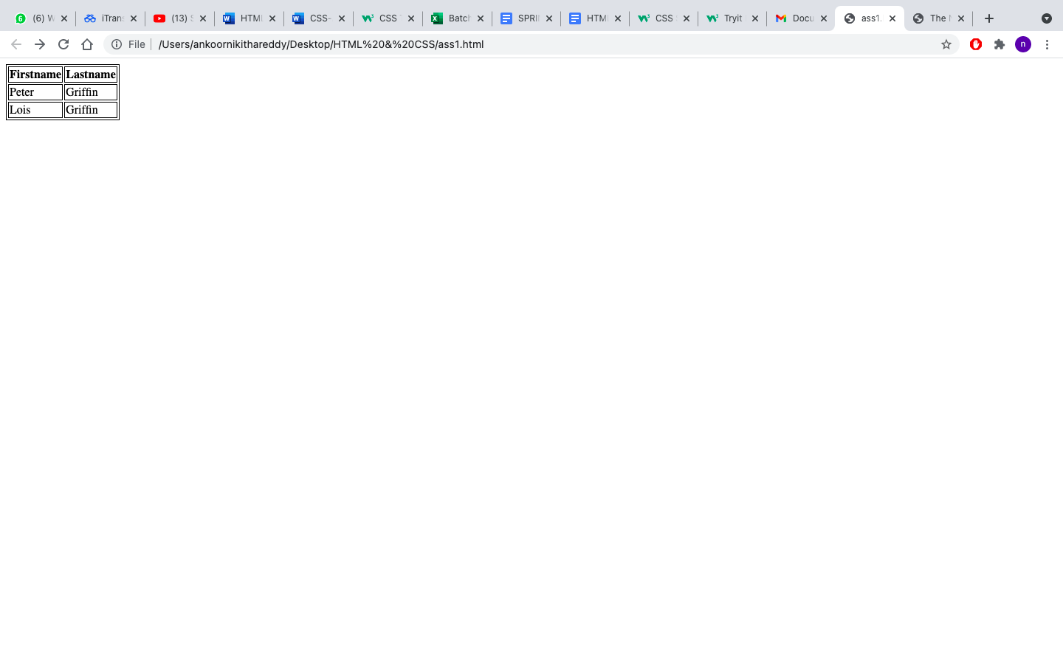

**7)index.html**

**<!DOCTYPE html>**

**<html>**

**<head>**

**<link rel="stylesheet" href="style1.css">**

**<body>**

**<p><b>Note: </b>IE8 supports the outline properties**

**only if a !DOCTYPE is specifies</p>**

**</body>**

**</head>**

**</html>**

**style1.css**

**p{**

**border: solid 2px red;**

**outline: dotted 3px yellowgreen;**

**}**

**Output:**

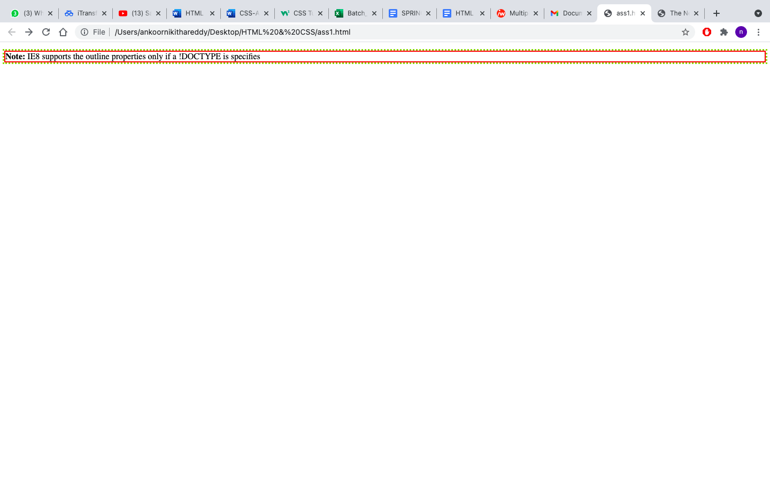

**8) Index.html**

**<!DOCTYPE html>**

**<html>**

**<head>**

**<link rel="stylesheet" href="style1.css">**

**<body>**

**<h2 class="text1">Some text</h2>**

**<h2 class="text2">Some text</h2>**

**<h2 class="text3">Some text</h2>**

**</body>**

**</head>**

**</html>**

**style.css**

**.text1{**

**background-color: lightblue;**

**border-style: solid;**

**border-width: 10px;**

**}**

**.text2{**

**background-color: lightblue;**

**border-style: solid;**

**border-width: 5px;**

**}**

**.text3{**

**background-color: lightblue;**

**border-style: solid;**

**}**

**Output:**

